- Title (Name of Club): KTS (No need to change)
- Faculty Coordinator: (No need to change)
- Related Information: (No need to change)
- Description: (No need to change)
Team Members: President: Vishuddhanand Manjhi, 3rd Year (CS), Vice-President: Suraj Singh, 3rd Year (CSE), Secretary: Stuti Agrawal, 3rd Year (CS), Technical Head: Yash Kumar Aggarwal, 3rd Year (CSE), Graphics Head: Shivendra keshari, 3rd Year (CS), Project Lead: Gurbani Kaur 3rd Year (CS), PR Head: Ishita Tyagi 3rd Year (CSE), ML Lead: Shephali Srivastava 3rd Year (IT).

- Website Url:N/A
- Snapshots:
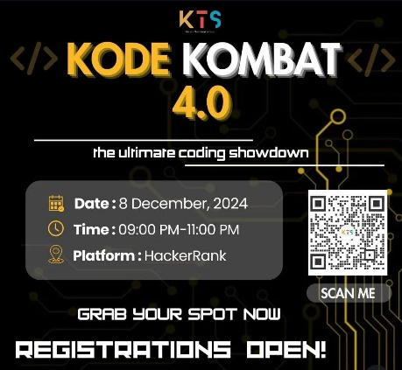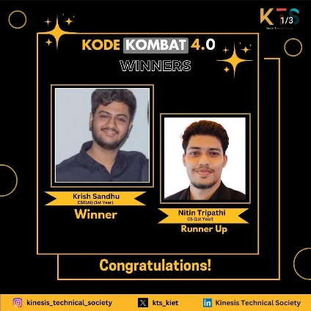
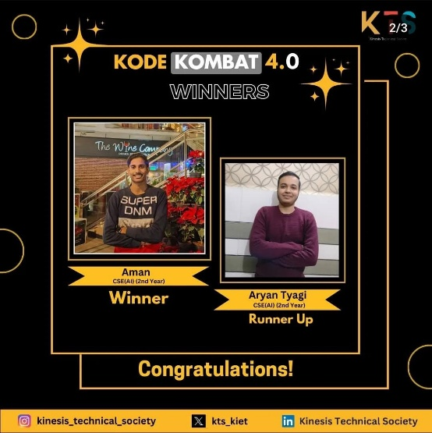
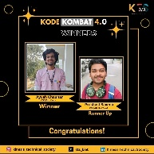

- Logo: (No need to change)

